(Approx. 735 words)

Book Review – Mastering Landscape Photography: Learn By Video
By Mark Mattson, Editor, Computer Users of Erie, PA
June 2012 issue, Horizons
www.cuerie.com
cuerie1 (at) verizon.net

This was somewhat of a different book review than all the others. Not only is it a book, it is also a complete video workshop on a DVD.

The book itself is a 28 page supplement to the DVD training videos. It presents supplemental materials that enhance the learning experience of the DVD. There is also a Glossary of terms at the end to clarify anything you may not be sure of.

The DVD is actually the star of this package. Produced by Austrian-based Video2Brain, it is one of their newest offerings in their series of training packages (release date of this title is December 31, 2011).

Your instructor for the video lessons is noted landscape photographer Phil Hawkins, who has shot many stunning images in and around the Yosemite area, as well as other subjects during his career (you can check his website at http://philhawkinsphoto.com/ ).

The workshop is comprised of four hours of High Definition video, all of which are accessed via the software player developed to make your learning experience smooth and seamless.

When you first open the DVD, you are presented with the user interface, which looks like this:

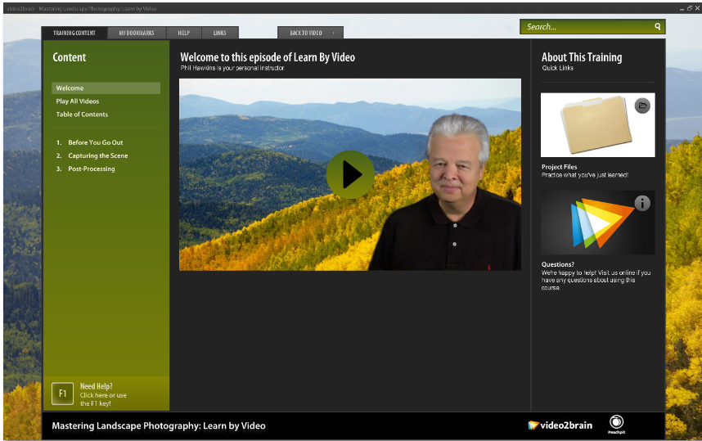

On the left side of the screen is the navigation area, where you can launch specific sections of the training, or choose to play all the videos in sequence. The central area is the video playback window, while the right side contains links to supplemental items.

The video quality is excellent, with saturated colors and high production standards throughout. You can choose to view the videos in the small window, but use the full screen view…you can lose yourself in the view, and almost think you’re on location.

The lessons are divided into three main sections:

1. Before You Go Out
2. Capturing the Scene
3. Post Processing

The first section covers the basics needed for successful landscape photography. Phil covers such details as choosing a good tripod, setting you camera for the best quality images, choosing the best lenses, and other vital information.

Capturing the Scene will teach you how to photograph for the best quality images. Topics covered in this section include how to read the histogram, exposure considerations, panoramic image capture, and others.

The final section, Post Processing, presents information on processing your images to further increase the quality of your captures. Here you will learn how to process your RAW files, workflow basics, and other topics. You will even learn how to process images for HDR. The key word to most of the processes covered here is that less is better. That is why you want to get it as close to a finished look in the camera when shooting your photos. Thus the need to view the entire disc, paying attention to all sections, particularly the first two. The less processing you need to do on your images to achieve the final print, the better.

Each section also contains a short Test Yourself section, where you can test your knowledge on what you’ve learned in each section.

Another advantage the interface gives you is the ability to bookmark sections of the disc you want to refer to at later times. Thus you can refer to sections of the disc you enjoy most, without having to search for them.

Mastering Landscape Photography: Learn By Video is available direct from the publisher, Peachpit for $27.99. As a member of CUE, you are eligible for the usual 35% discount when you buy from them (this brings it down to $18.19). This is lower than what Amazon.com charges, so you can save yourself about $8 when buying from Peachpit. Go to www.peachpit.com to purchase.

Is this video worth the purchase? Definitely, especially if you are hooked on landscape photography, either as a hobby, or a way to make an income. The techniques and information presented are well worth the purchase price, and give you a solid basis to build upon in the future, as your skills improve and grow.

Even though the author lives in the western US (California), the information would apply just as well to anywhere in the world. True, certain locales would require some adaptations or modifications to what is presented here (such as shooting techniques for snowy locations), but you would learn those by experience and growing your knowledge over time.

If you want to learn landscape photography, this is an excellent place to start your journey.

